**Assignment: Bash Shell Basics**

***NAME:POOVARASAN.A***

***REG.NO:20BCI0194***

**Task 1: File and Directory Manipulation**

1. Create a directory called "my_directory".

**Commands used:**mkdirmy_directory

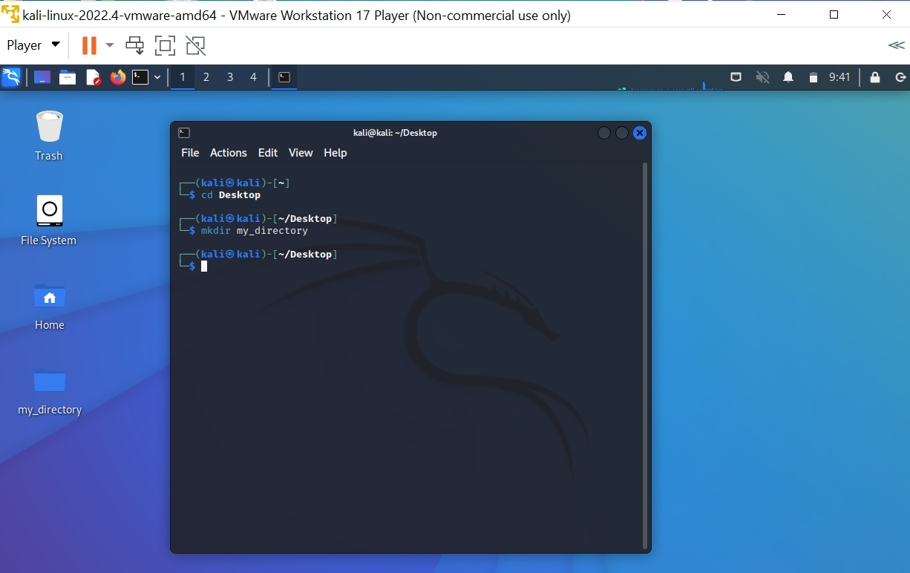

2. Navigate into the "my_directory".

**Commands used:**cd my_directory

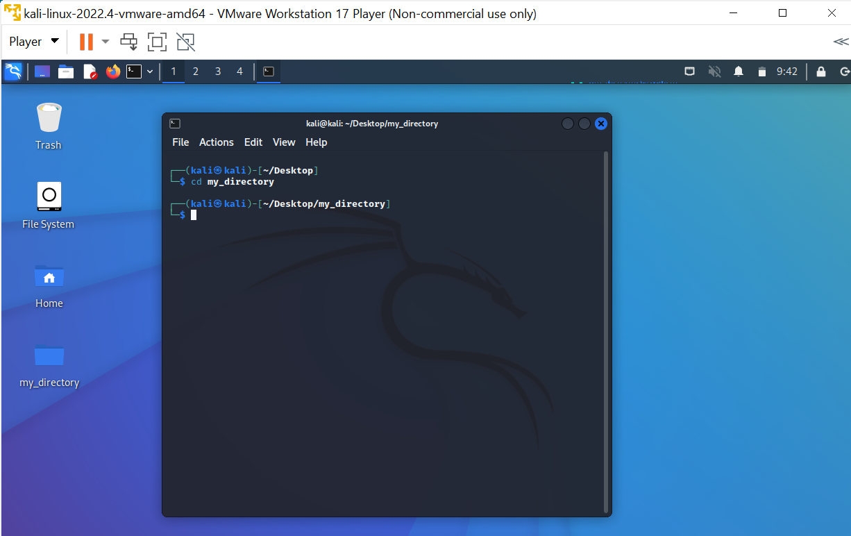

3. Create an empty file called "my_file.txt".

**Commands used:**touch my_file.txt

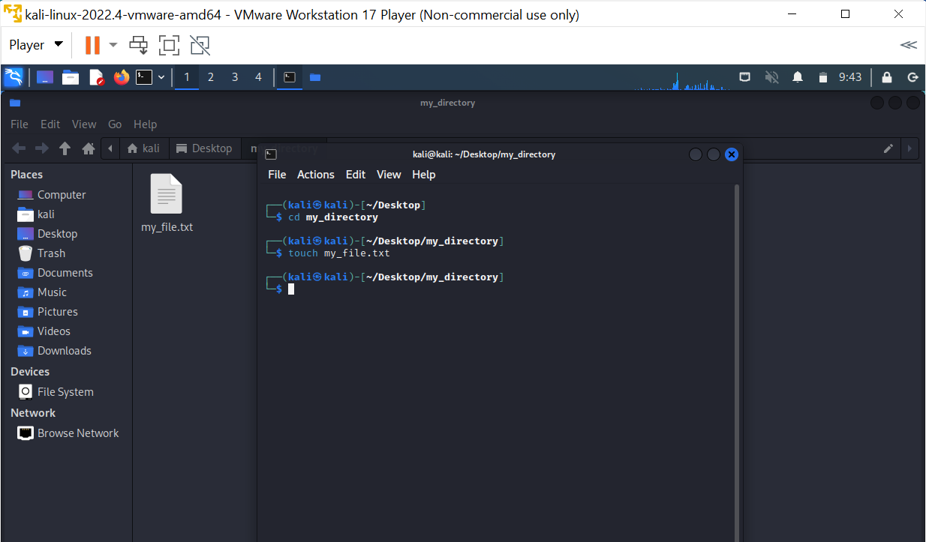

4. List all the files and directories in the current directory.

**Commands used:**ls

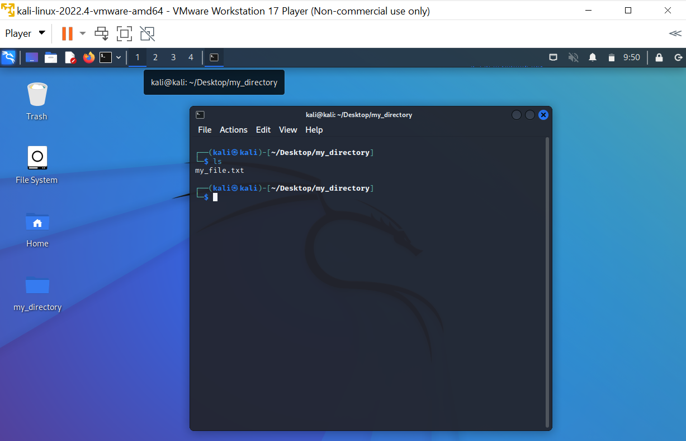

5. Rename "my_file.txt" to "new_file.txt".

**Commands used:**mv my_file.txt new_file.txt

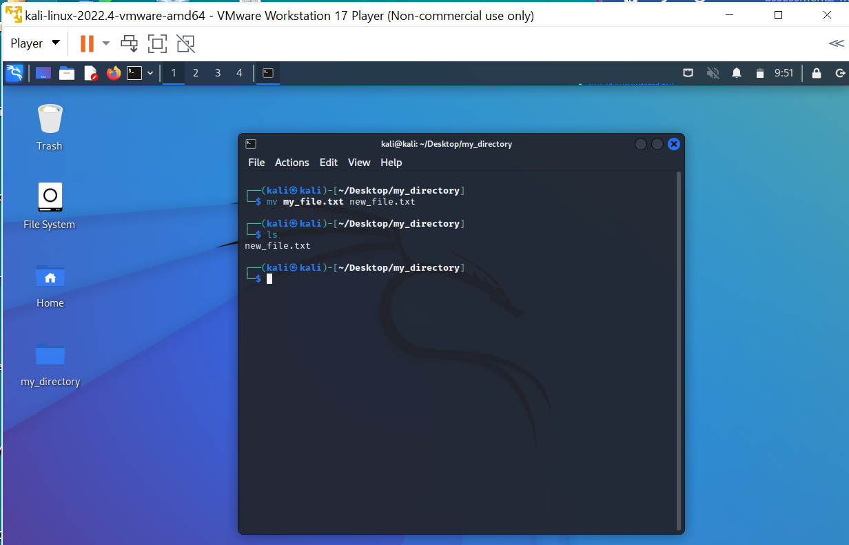

6. Display the content of "new_file.txt" using a pager tool of your choice.

**Commands used:**cat new_file.txt (the file is empty)

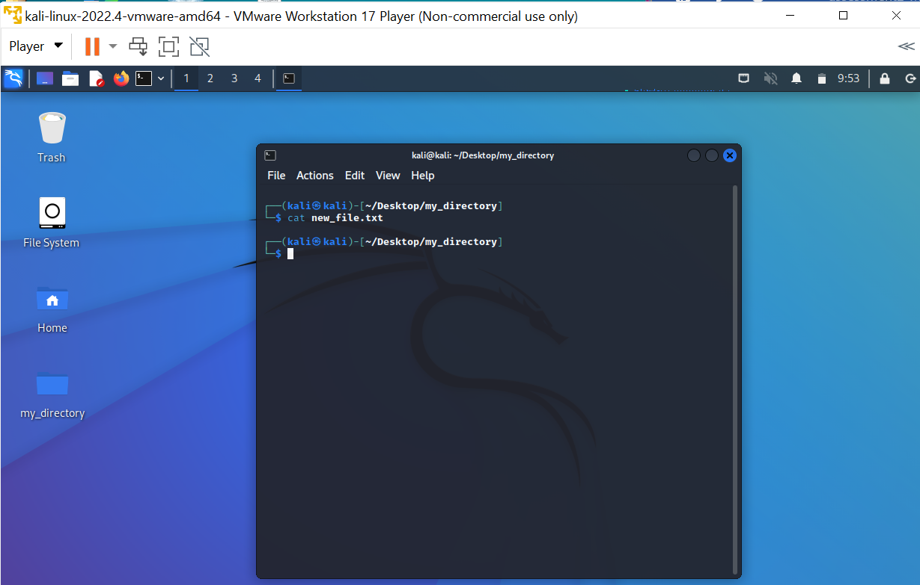

7. Append the text "Hello, World!" to "new_file.txt".

**Commands used:**cat > new_file.txt

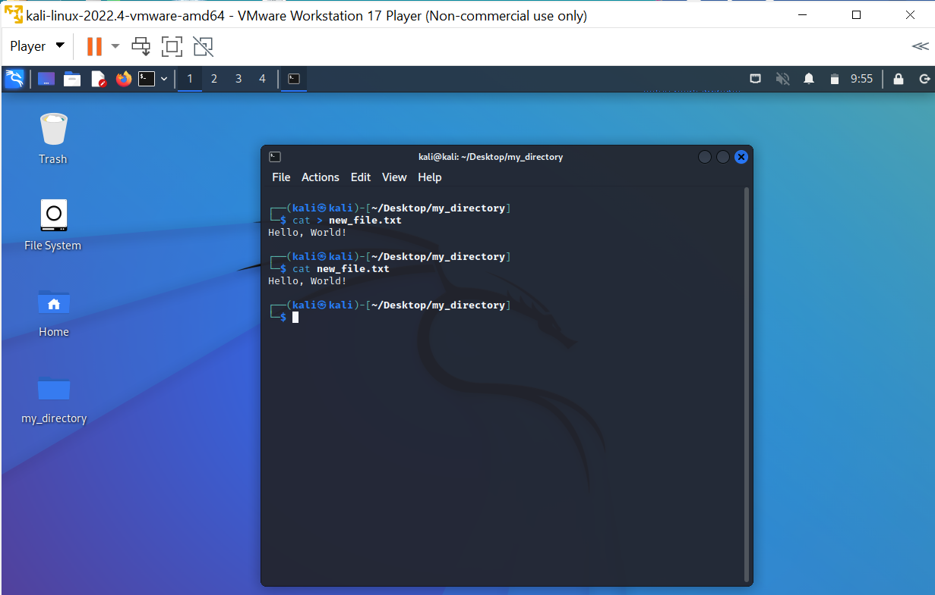

8. Create a new directory called "backup" within "my_directory".

**Commands used:**mkdir backup

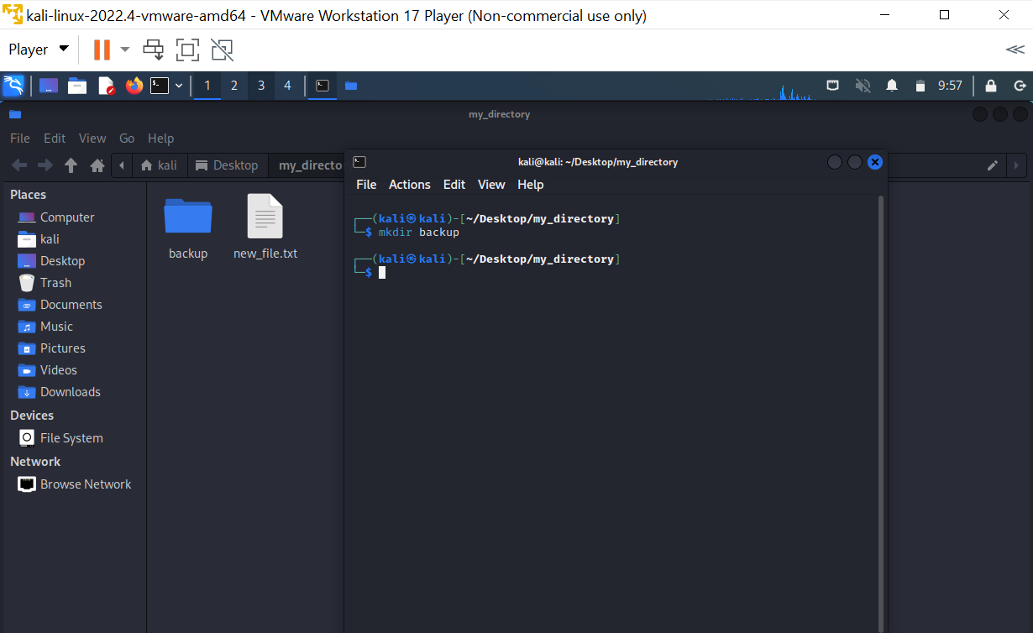

9. Move "new_file.txt" to the "backup" directory.

**Commands used:**mv new_file.txt /home/kali/Desktop/my_directory/backup

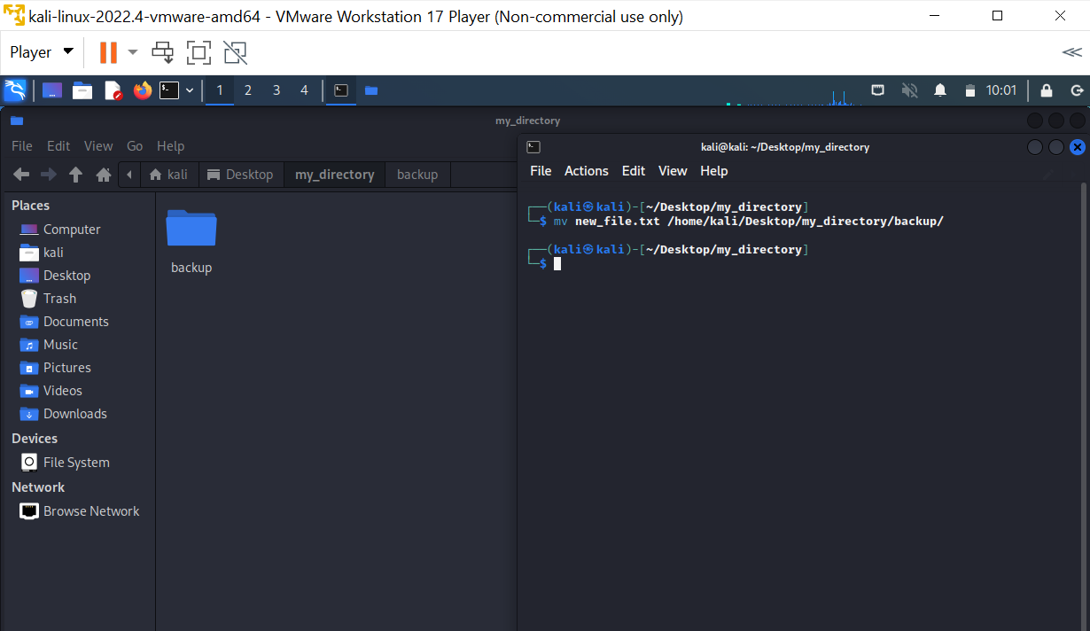

10. Verify that "new_file.txt" is now located in the "backup" directory.

**Commands used:**ls

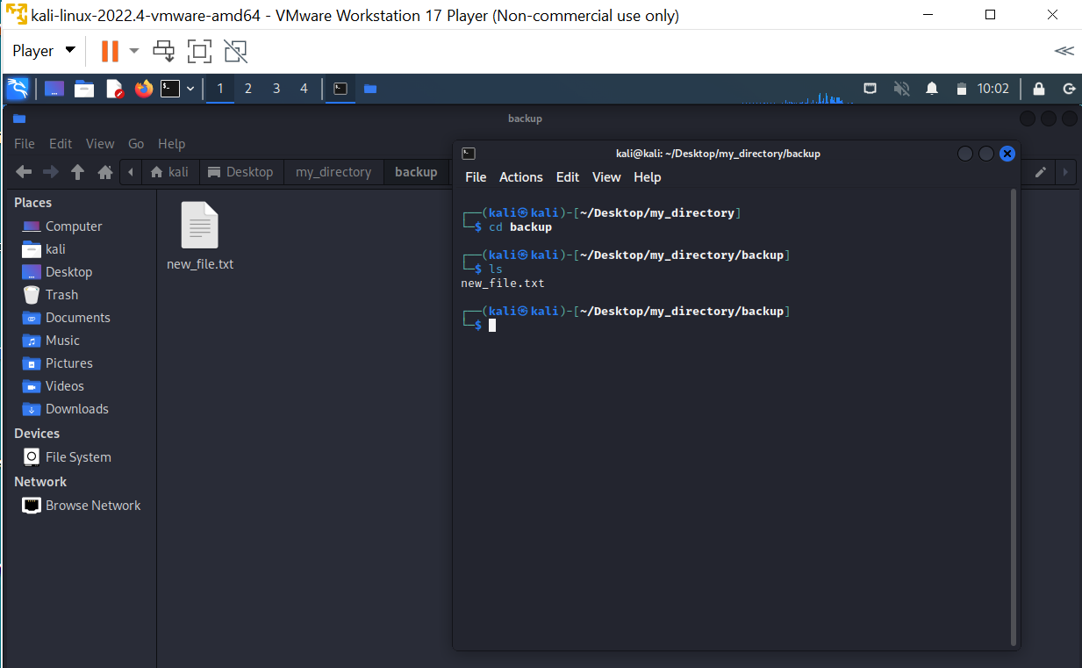

11. Delete the "backup" directory and all its contents.

**Commands used:**rm -r backup

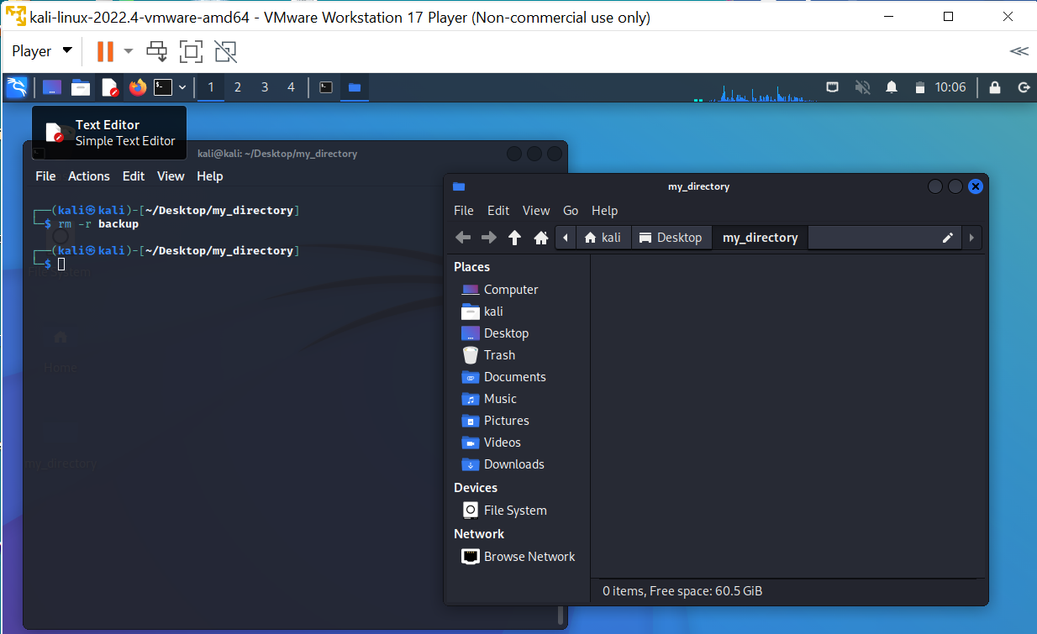

**Task 2: Permissions and Scripting**

● Create a new file called "my_script.sh".

**Commands used:**touch my_script.sh

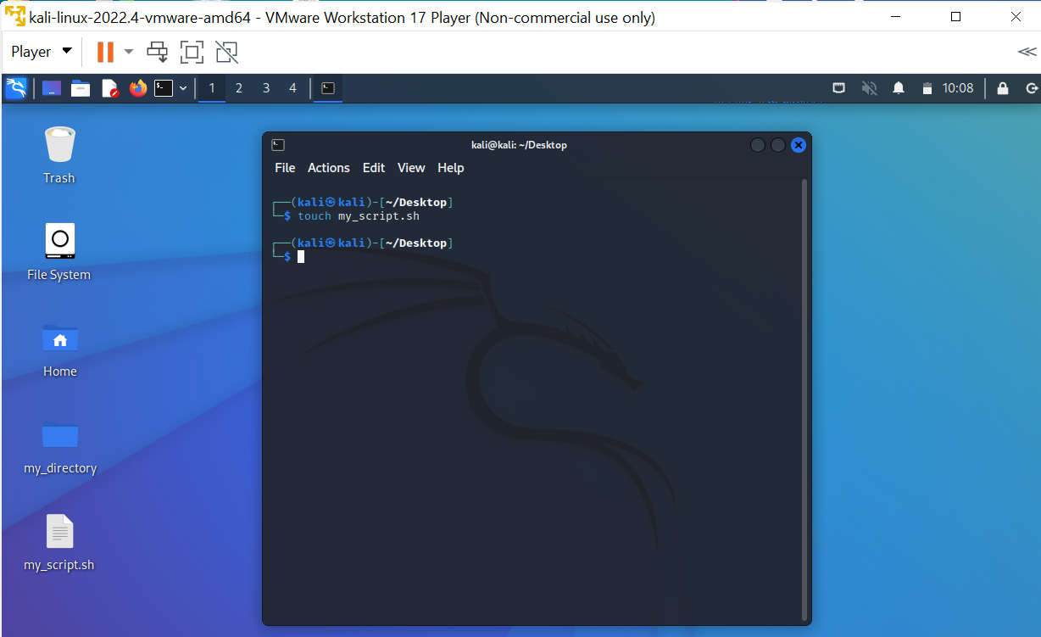

● Edit "my_script.sh" using a text editor of your choice and add the following lines:bash

**#!/bin/bash**

**echo "Welcome to my script!"**

**echo "Today's date is $(date)."**

**Save and exit the file.**

**Commands used:**nano my_script.sh

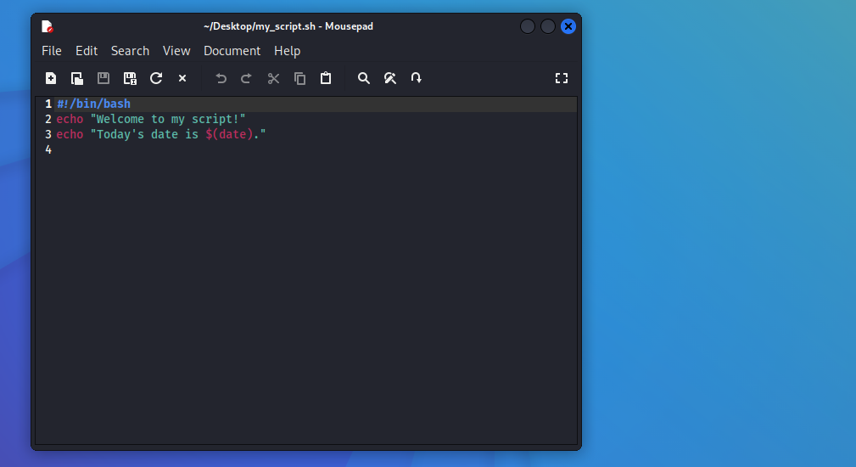

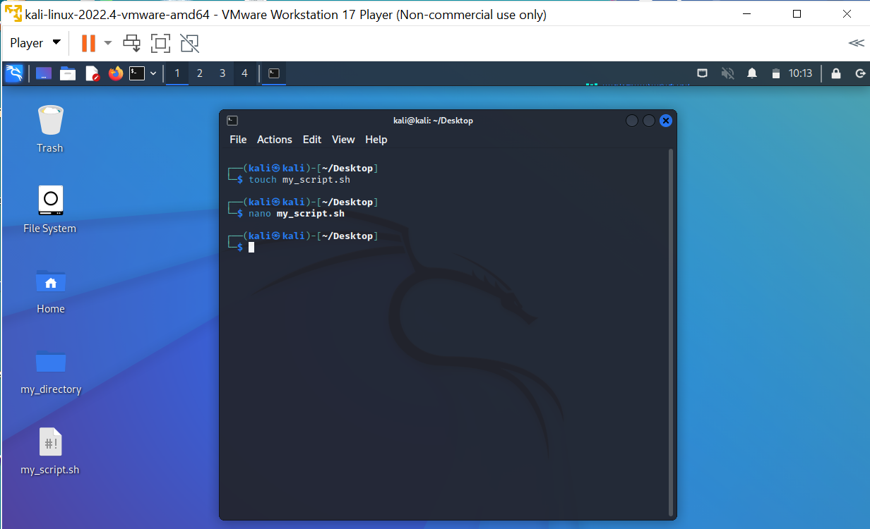

● Make "my_script.sh" executable.

**Commands used:**chmodu+x my_script.sh

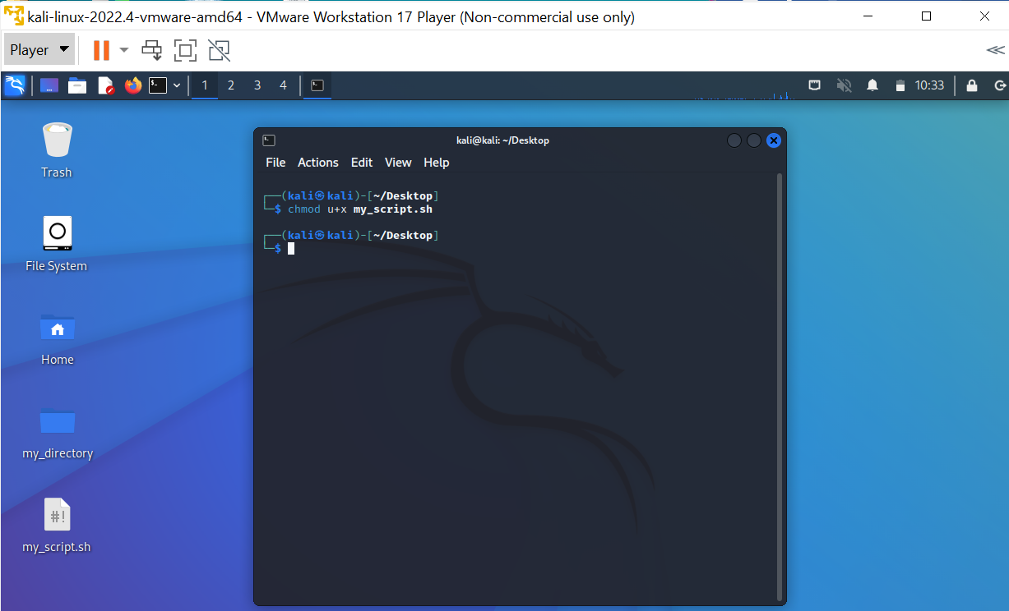

● Run "my_script.sh" and verify that the output matches the expected result.

**Commands used:**./my_script.sh

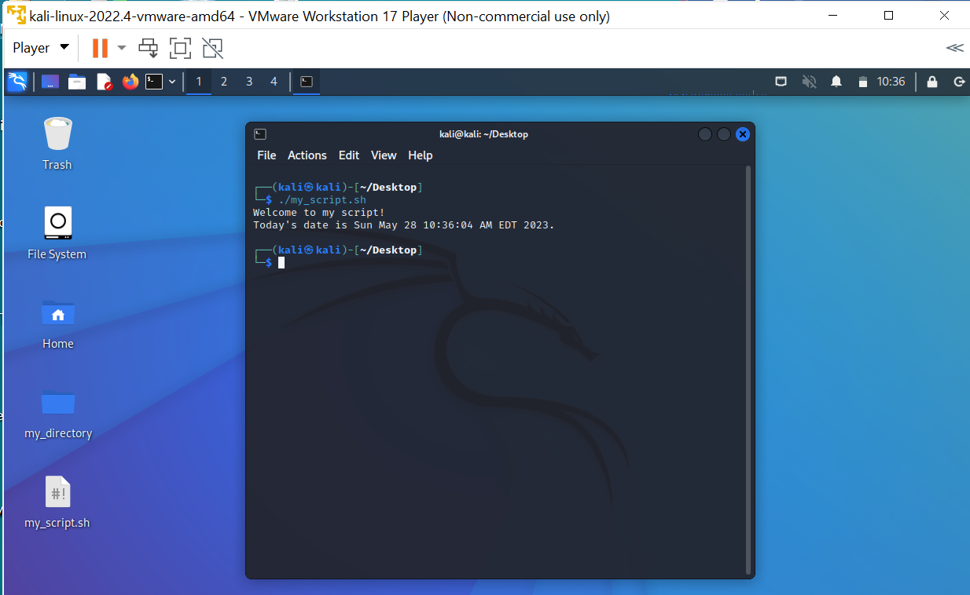

**Task 3: Command Execution and Pipelines**

● List all the processes running on your system using the "ps" command.

**Commands used:**ps – this command lists the active processes and their PIDs

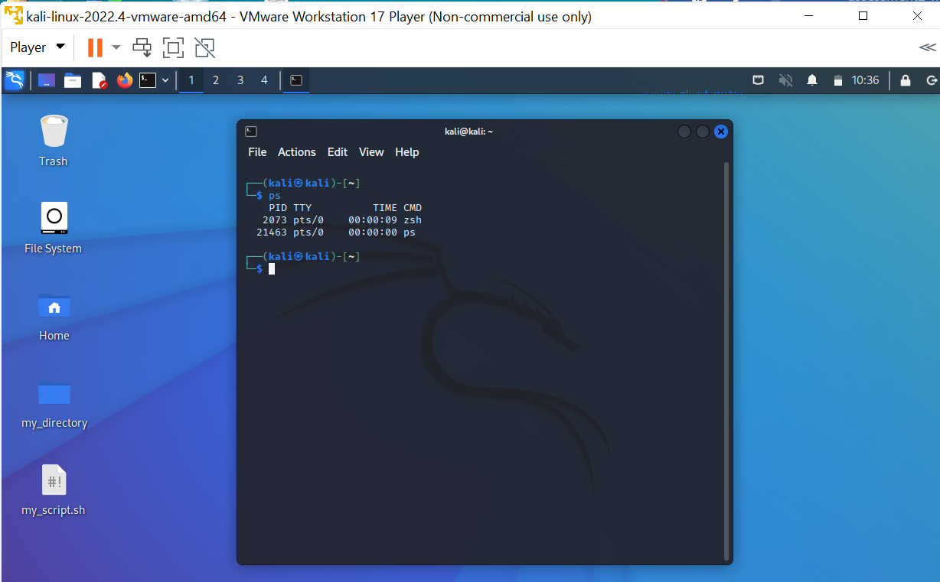

● Use the "grep" command to filter the processes list and display only the processes with"bash" in their name.

**Commands used:**ps aux | grep ‘bash’

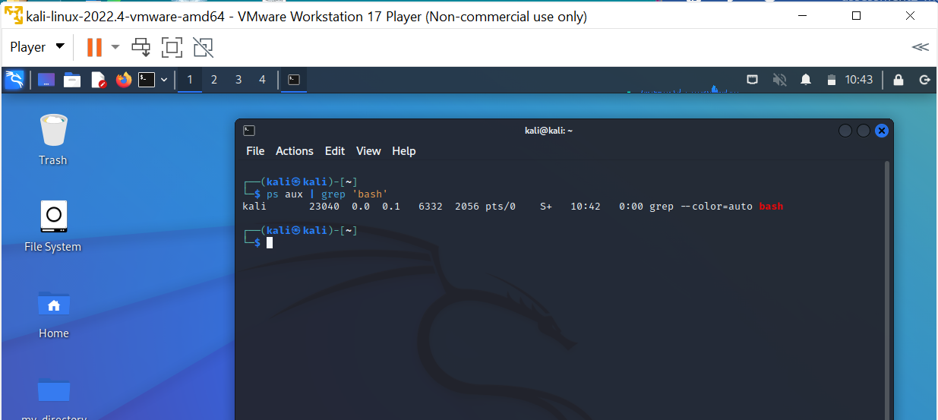

● Use the "wc" command to count the number of lines in the filtered output.

**Commands used:**ps aux | grep ‘bash’ | wc

